5.1 Approximating Areas

In Chapters 1 – 4 we have looked at the application of limits as it related to tangent lines and their slopes. In Chapter 5 turn our attention to a seeming unrelated question of using limits to help determine areas.

General Idea (Part I):
A car is traveling at a constant rate of 50mph for a 2-hour period. Find the total change in position. Represent this quantity as an area on a graph.

Note: When the rate of change of a quantity is positive, the total change in that quantity on some interval can be represented by the area between a function and the horizontal axis on that interval.

General Idea (Part II):
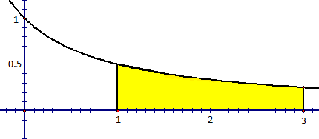
An object travels at ft/sec between the times and seconds. Estimate the total change in position of the object during this time.

Exploration: The area A of the region S that lies under the graph of the continuous function f can be approximated by using sum of areas of n approximating rectangles.
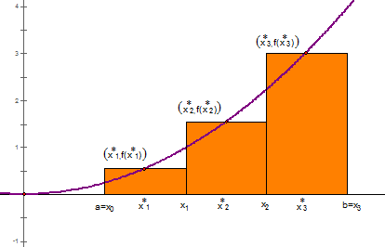
If
- each rectangle has an equal width

- each rectangle has height

Then the area of each rectangle will be given by the formula

Therefore the approximation of the area will be given by

Definition: The net area (also called signed area) of a region that lies between the x-axis and the graph of a continuous function may be approximated with a Riemann sum which is a sum of the form

Common Riemann Sums:
- A Left Riemann Sum has the top left corner of each rectangle on the function.
- A Right Riemann Sum has the top right corner of each rectangle on the function.
- A Midpoint Riemann Sum has the midpoint of the top side of each rectangle on the function.

Example 1: Let A be the area of the region that lies above the x-axis and under the graph of between .
- Estimate the area by using a Left Riemann Sum with 4 rectangles.

- Estimate the area by using a Right Riemann Sum with 4 rectangles.

- Estimate the area by using Midpoint Riemann Sum with 8 rectangles.

Note: If f takes on both positive and negative values, then the rectangles above the x-axis have positive area and the rectangles below the x-axis have a negative area.

Example 2: Let A be the area of the region that lies between the x-axis and between .

- Estimate the area by using a Riemann sum with left endpoints and 3 rectangles.

- Estimate the area by using a Riemann sum with right endpoints and 6 rectangles.

Example 3: Suppose the odometer on our car is broken and we want to estimate the distance driven over a $30$ minute time interval. We take the speedometer readings every 5 minutes and record them in the following table:
Time (hours) | 0 | 1/12 | 2/12 | 3/12 | 4/12 | 5/12 | 6/12
Velocity(mi/h) | 17 | 21 | 24 | 29 | 32 | 31 | 28

- Estimate the distance traveled using left endpoints.

- Estimate the distance traveled using right endpoints.

